Statistics for data science : Study material

Introduction:

A branch of mathematics dealing with the collection, compilation,analysis and interpretation of numerical data. We can say its science of counting or science of averages. Is all about understanding and interpreting data. Requires strong communication skills in order to discuss data and any problems surrounding it can be used in various fields from simple to complex. Its also defined as the science of estimates and probabilities.

Statistical methods is the branch which deals with the general procedure of statistical analysis of numerical data . Applied statistics deals with the application of statistical devices and techniques in the analysis of the data relating to other sciences.
Statistics is to find the variation among the different subjects. If there is no variation, there is no need for statistics

Uses of Statistics:
Its main use is in research tasks.

Quantitative research as numerical data
Descriptive statistics - summarize the utility, efficacy and costs of medical goods and services. Analysis to measure their performance outcomes. Researchers employ scientific methods to gather data on human population samples. "demographic" statistics can predict the types of services that people are using and the level of care that is affordable to them . Development of statistical methods to deal with problems arising out of health and diseases It can be used in application in Medical research

Types of data/variables
Data types are important concepts in statistics, they enable us to apply statistical measurements correctly on data and assist in concluding certain assumptions about it. A variable is a characteristics or condition that can change or take on different values.
There are two types of data ,
1. Qualitative Data
2. Quantitative Data
Qualitativedata: Qualitative data is a bunch of information that cannot be measured in the form of numbers. It is also known as categorical data. It normally comprises words, narratives, and we labelled them with names. It delivers information about the qualities of things in data. The outcome of qualitative data analysis can come in the type of featuring key words, extracting data, and ideas elaboration.
- • Example: Hair colour- black, brown, red
- • Opinion- agree, disagree, neutral
- Gender Male, female

Quantitative data is a bunch of information gathered from a group of individuals and includes statistical data analysis. We can measure it. Hence measurable data is called quantitative. Here the data can be estimated. And, we can formulate them in terms of numbers. The quantitative data can be classified as discrete data and continuous data. Continuous data take any value from –infinity to + infinity. But Discrete data contains only integer number like 1,2,3,…..Whereas continjuous data takes value inbetween the two integer values that means fractionsi
Example for continuous data : weight,height , Income, age etc
For discrete data ; Number of students in the class, Pulse rate etc..

Scales of Measurements :
measurement scale, in statistical analysis, the type of information provided by numbers. Each of the four scales (i.e., nominal, ordinal, interval, and ratio) provides a different type of information. Measurement refers to the assignment of numbers in a meaningful way, and understanding measurement scales is important to interpreting the numbers assigned to people, objects, and events.
1.Nominal Scale: In nominal scales, numbers, such as driver’s license numbers and product serial numbers, are used to name or identify people, objects, or events. And they are independent properties. Eg:name,gender,religion.

2.Ordinal scale: In ordinal scales, numbers represent rank order and indicate the order of quality or quantity, but they do not provide an amount of quantity or degree of quality. And it is independent but also grading system. Eg:distinction,first class., second class etc.

3.Interval scale: In interval scales, provide information about the amount of difference, but the scale lacks a true zero.ie,if 0 has any value it comes under intervals scale . example : Temperature
4.Ratio scale: Ratio scales have all of the characteristics of interval scales as well as a true zero, which refers to complete absence of the characteristic being measured. Physical characteristics of persons and objects can be measured with ratio scales, and, thus, height and weight are examples of ratio measurement. A score of 0 means there is complete absence of height or weight. A person who is 1.2 metres (4 feet) tall is two-thirds as tall as a 1.8- metre- (6-foot-) tall person. Similarly, a person weighing 45.4 kg (100 pounds) is two-thirds as heavy as a person who weighs 68 kg (150 pounds). Which is not true in interval scale

What is Data Collection?
In Statistics, data collection is a process of gathering information from all the relevant sources to find a solution to the research problem. It helps to evaluate the outcome of the
problem.
The data collection method is divided into two categories namely
Primary Data, Secondary Data
Primary Data
Primary data or raw data is a type of information that is obtained directly from the first-hand source through experiments, surveys or observations.This method is good, Non bias but costly
Secondary data : are those which have been collected by someone else and which have already been passed through the statistical process. Here expenditure is less but whatever
Information we need, that cannot be taken. We can study whatever is there in the records
Method of Collection : Primary data
1.Observation Method: observation by observer
“Observation may be defined as systematic viewing ,coupled with consideration of seen phenomenon - P.V. Young
2. Interview method : Oral-verbal responses
a.. Personal interviews: Direct personal interview and Indirect personal interview
b. Telephonic interviews
c. Structured interviews
d. Unstructured interviews
e. Group interviews
f. Depth interviews
g. Postal interviews/email/google
Characteristics of Observation method :
1.useful in social and anthropological study
2.useful in experimental and nonexperimental study also
3. just observing and noting the phenomenon.
4. Bias is very less.
5. All the information what you collect is present not past
6.Respondents willingness is not necessary(Informed consent form)
7.but the information provided by this method is limited.
Interview method
1. Standardised, structured interviews
2. Un standardised , unstructured interview
3.Semistructured interviews
Standardised structured interviews
Formal interviews where set of predetermined and highly standardized questions in a systematic way will be collected. Not allowed to deviate from the standardized proforma . Moreover they are not free to adopt his/her questions to the specific situations.
Merits:
1.Comparability is high
2.Analysis is easy
3. More economical
4.Provides basis for generalization of the results
Unstandardised ,unstructured interview
Informal interview whereas flexibility of approach can be seen.
No need of pre determined questions. Interviewer is free to develop new questions
He may supplement /omit// change questions. This is helpful in exploratory studies
Semi standardised, Semi structured
Focussed interviews, Preparatory thinking and recording the interview
Closing the interview

Rules of Interview
Choose a suitable time and place for interview. Make a gradual approach by developing good rapport. Allow the respondents to ask questions to clear their doubts.
The questions should be easy to understand. It should not be embarrassing . Be friendly , Patient listener, Do not argue with the respondents. Think twice before giving advise. You should never act as a teacher, doctor, Professional..Give them ample time to answer

Questionnaire
The type of technique used in the Questionnaire method is Quantitative. In the Questionnaire method, the grouping is made on the basis of different categories like location, age, gender etc. In Questionnaires, responses are filled by the respondents.
The response rate of the Questionnaire method is low compared to the Schedule method.

Schedule
The type of technique used in the Schedule method is Qualitative
In the schedule method of data collection, the grouping may exist or may not exist.
In Schedule, method responses are filled by the enumerators themselves..
The response rate in the Schedule method of data collection is high.

Frequency distribution table

A frequency distribution table is a chart that summarizes all the data under two columns - variables/categories, and their frequency. It has two or three columns. Usually, the first column lists all the outcomes as individual values or in the form of class intervals, depending upon the size of the data set.

Types of Frequency Distribution
There are different types of frequency distributions, including grouped and ungrouped distributions as well as joint distributions. Moreover, the type of data can be either quantitative (numbers) or qualitative (verbal descriptions).

Grouped and Ungrouped
So far, we have only looked at ungrouped frequency distributions, which are distributions in which data values are not grouped (i.e., the first column is all single data values). In some circumstances, it may be useful to group together multiple data values, typically when there is a large number of unique values. This is called a grouped frequency distribution.
For instance, to construct a frequency distribution table with the heights of a large number of people, it may be more manageable to group together certain heights into distinct intervals or ranges, such as 5'0"-5'2", 5'3"-5'5", 5'6"-5'8", and so on. You would put these intervals in the first column of the table and the number of data values are marked by tally mark method and that fall within each interval comes as a frequency in the third column. . The size of these intervals can be adjusted depending on how many intervals are desired. This is called as inclusive class interval where lower and upper limits are included in the same class interval.

Q)Here's a frequency distribution table example for you to understand this concept better. Jane is fond of playing games with dice. She throws the dice and notes the observations each time. These are her observations: 4, 6, 1, 2, 2, 5, 6, 6, 5, 4, 2, 3. To know the exact number of times she got each digit (1, 2, 3, 4, 5, 6) as the outcome, she classifies them into categories. An easy way is to draw a frequency distribution table with tally marks.

Outcomes | Tally Marks | Frequency
1 | I | 1
2 | I I I | 3
3 | I | 1
4 | I I | 2
5 | I I | 2
6 | I I I | 3

Frequency Distribution Table for Grouped Data
A frequency distribution table for grouped data is known as a grouped frequency distribution table. It is based on the frequencies of class intervals. As it is already discussed above that in this table, all the categories of data are divided into different class intervals of the same width,. To prepare the class I ntervals and the width of the class interval we have small formula. Decide on the number of classes using the formula
2^{k} > n where k=number of classes After obtaining k find the width of the class interval by the formula
I >= H –L / k where H- the highest number in the given data and L- lowest number in the data. After obtaining the width of the class I nterval prepare the different class interval.
Suppose we have 50 samples then k becomes 6 as
2^{k} = 2⁶ =64 which is more than 50 hence k=6 is the number of class intervals .
If in our given data ,lowest value is 5 and the maximum value 50 thern
I = 50 -5 / 6 =45 / 6 =7.5 = 8 so our class I ntervals are
5- 13, 13- 21 , 21- 29, 29 – 37, 37- 45 , 45- 52
After obtaining the frequency you can also estimate the relative frequency, Cumulative frequency and the percentage from the data
Relative frequency = Frequency of particular class interval/ Total frequency. If you multiply the relative frequency by 100 for each class interval you get the percentage, Cumulative frequency means adding the frequency row wise. For example in the exercise given above
Marks scored | Frequency | Relative frequency | Cumulative frequency | Percentage
30 -40 | 5 | 0.05 | 5 | 5
40 -50 | 15 | 0.15 | 20 | 15
50 – 60 | 12 | 0.12 | 32 | 12
60 – 70 | 25 | 0.25 | 57 | 25
70 – 80 | 20 | 0.20 | 77 | 20
80 – 90 | 13 | 0.13 | 90 | 13
90 -100 | 10 | 0.10 | 100 | 10
Total | 100 | 1 |  | 100

There are two types of class intervals are there. Inclusive class interval and Exclusive class Interval. Inclusive class interval we take the number by including the lower limit and the upper limit in the same class interval. For eg. Suppose we have 10 -19, 20 – 29, 30 -39… and so on then number 10 and 19 both includes in the same class interval of 10 – 19. But in the exclusive class interval we don’t include the data in the upper limit but we take in the lower limit of the next class interval. For eg. The interval will be 10 – 20, 20 – 30, 30 – 40, …… In this case number 20 will not be taken in the first class Interval, but it will go to the next class interval as frequency. Similarly 30 will be taken as frequency in the thirds class interval and so on.

Diagrammatic and graphical presentation:

Statistical data , when written in the tabular form are not easily understood by common men. So diagrammatic and graphical presentation are more appealing. Hence diagrams and graphs are needed for presentation of data.
Uses of diagrams
- They are attractive
- They can be easily understood by common men
- They facilitate comparison of various characteristics
- Theorems and results of statistics in advanced statistics are better understood with the aid of the graph
Types of Graphs or diagrams used for qualitative data
Bar charts: A Bar chart can be used to depict any of the level of measurement (Nominal, ordinal, interval or ratio).
Bar chart is a popular and easy method adopted for visual comparison of the magnitude of different frequencies. In discrete data, such as of morbidity, mortality , vaccinationl status of population in different ages, sexes, professions or places.
Different types of Bar diagrams are-
- 1. Simple bar diagram
- 2. Multiple bar diagram
- 3. Component bar diagram
- 4. Percentage bar diagram

Simple Bar chart
A bar chart consists of a grid and some vertical or horizontal columns (bars). Each column represents quantitative data.
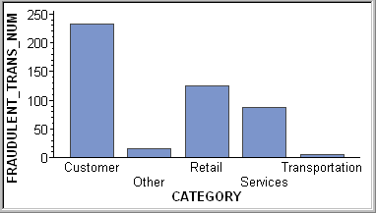

Multiple bar chart

When we have more than one variable to shown in the same chart we can use multiple bar chart for presentation

Title: Expenditure status of the Cases and controls

Component bar chart;

Here in each category the data is divided into different components and the same will be shown as below: Here the items are represented by rectangular bars of equal width and height proportional to magnitude. Then the bars are divided so that the subdivisions in height represent the components. To distinguish the components from one another clearly different colors can be applied.

Percentage Bar charts;

Percentage bar charts are drawn to represent items whose magnitude have two or more components and when a comparison of the components as percentage is required. Here the components are expressed as percentages of the corresponding totals.

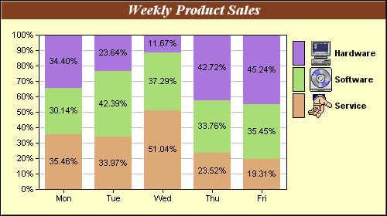

Pie Charts
A pie chart is a pictorial representation of data in the form of a circular chart or pie where the slices of the pie show the size of the data. A list of numerical variables along with categorical variables is needed to represent data in the form of a pie chart. The arc length of each slice and consequently the area and central angle it forms in a pie chart is proportional to the quantity it represents. Pie charts, also commonly known as pie diagrams help in interpreting and representing the data more clearly. It is also used to compare the given data.

Steps to Construct Pie Chart
We use the following steps to construct a pie chart and using the above-mentioned formulas, we can calculate the data.
- Step 1: Write all the data into a table and add up all the values to get a total.
- Step 2: To find the values in the form of a percentage divide each value by the total and multiply by 100.
- Step 3: To find how many degrees for each pie sector we need, we take a full circle of 360° and use the formula: (Frequency/Total Frequency) × 360°
- Step 4: Once all the degrees for creating a pie chart are calculated, draw a circle (pie chart) using the calculated measurements with the help of a protractor.

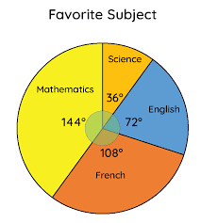

Graphs for quantitative data:

The three commonly used graphs for quantitative data are Histograms, Frequency polygon and frequency curve

Histograms
A histogram is a bar chart that displays the observed frequencies of data that have been binned (divided into continuous, equally spaced intervals). The heights of the bars indicate the relative frequency of observations in each bin. Histograms can also show binned response data if you choose a response variable other than Frequency.

How to Plot Histogram?
You need to follow the below steps to construct a histogram.
- Begin by marking the class intervals on the X-axis and frequencies on the Y-axis.
- The scales for both the axes have to be the same.
- Class intervals need to be exclusive.
- Draw rectangles with bases as class intervals and corresponding frequencies as heights.
- A rectangle is built on each class interval since the class limits are marked on the horizontal axis, and the frequencies are indicated on the vertical axis.
- The height of each rectangle is proportional to the corresponding class frequency if the intervals are equal.
- The area of every individual rectangle is proportional to the corresponding class frequency if the intervals are unequal.
Although histograms seem similar to graphs, there is a slight difference between them. The histogram does not involve any gaps between the two successive bars.

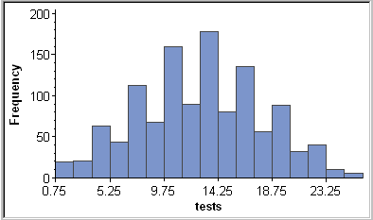

Difference Between Bar Graph and Histogram
A histogram is one of the most commonly used graphs to show the frequency distribution. As we know that the frequency distribution defines how often each different value occurs in the data set. The histogram looks more similar to the bar graph, but there is a difference between them. The list of differences between the bar graph and the histogram is given below:
Histogram | Bar Graph
Used for continuous data | Used for qualitative data
It is a two-dimensional figure | It is a one-dimensional figure
The frequency is shown by the area of each rectangle | The height shows the frequency and the width has no significance.
It shows rectangles touching each other | It consists of rectangles separated from each other with equal spaces.

A

Frequency Polygon
consists of line segments connecting the points formed by the class midpoint and the class frequency.
A frequency polygon is almost identical to a histogram, which is used to compare sets of data or to display a cumulative frequency distribution. It uses a line graph to represent quantitative data.

Steps to Draw Frequency Polygon
To draw frequency polygons, first we need to draw histogram and then follow the below steps:
- Step 1- Choose the class interval and mark the values on the horizontal axes
- Step 2- Mark the mid value of each interval on the horizontal axes.
- Step 3- Mark the frequency of the class on the vertical axes.
- Step 4- Corresponding to the frequency of each class interval, mark a point at the height in the middle of the class interval
- Step 5- Connect these points using the line segment.
- Step 6- The obtained representation is a frequency polygon.
Let us consider an example to understand this in a better way.

Example
Example 1: In a batch of 400 students, the height of students is given in the following table. Represent it through a frequency polygon.
Height(cm) | Number of students
140 -150 | 74
150 - 160 | 163
160 - 170 | 130
170 - 180 | 33
Total | 400

Solution: Following steps are to be followed to construct a histogram from the given data:
- The heights are represented on the horizontal axes on a suitable scale as shown.
- The number of students is represented on the vertical axes on a suitable scale as shown.
- Now rectangular bars of widths equal to the class- size and the length of the bars corresponding to a frequency of the class interval is drawn.

Same way you can prepare the frequency curve by joining the points by smooth curve

MEASURES OF CENTRAL TENDENCY

A measure of central tendency (also referred to as measures of center or central location) is a summary measure that attempts to describe a whole set of data with a single value that represents the middle or center of its distribution.
Measures of central tendency help you find the middle, or the average, of a data set. The 3 most common measures of central tendency are the mode, median, and mean.

Generally, the central tendency of a dataset can be described using the following measures:
Mean (Average): Represents the sum of all values in a dataset divided by the total number of the values.

Median: The middle value in a dataset that is arranged in ascending order (from the smallest value to the largest value). If a dataset contains an even number of values, the median of the dataset is the mean of the two middle values.

Mode: Defines the most frequently occurring value in a dataset. In some cases, a dataset may contain multiple modes, while some datasets may not have any mode at all.

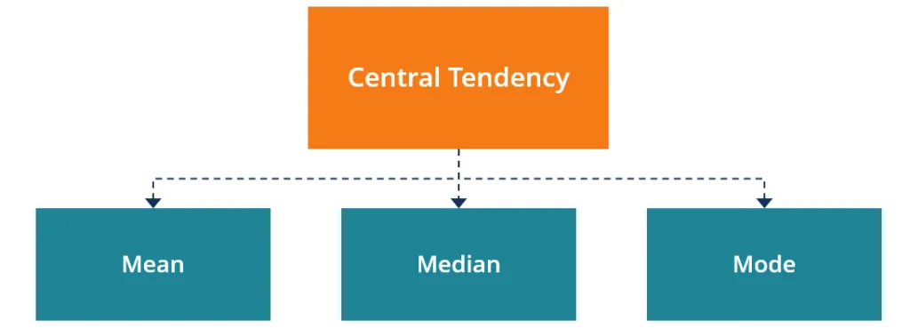
Different measures of central tendency
1. Mean :
1. Arithmetic mean
2. Harmonic mean
3. Geometric mean
4. Weighted mean
2. Median
3. Mode
4. Quartiles
5. Deciles
6. Percentile

QUALITIES OF A GOOD MEASURE OF CENTRAL TENDENCY

Rigidly defined: In some cases, would considerably affect the value of the average. If the average is rigidly defined, this instability in its value would be no more, and it would always be a definite figure
Based on all observation: To ensure that is should represent the entire data set, it’s value should be calculated by taking into consideration the entire data set.
Easy to understand and calculate: The value of an average should be computed by using a simple method without reducing its accuracy and other advantages
Algebraic treatment: It should have capable of further algebraic treatment. In other words, an ideal average is one which can be used for further statistical calculation.
Mathematical formula: Usually it defined in a form of mathematical formula. there are different formulas for finding average of different types of Problems.

Mean
Mean is the measure of the average of a set of values which can be calculated by dividing the sum of all the observations by the number of observations. There are four different ways to measure the mean of a data set. They are arithmetic mean, geometric mean, harmonic mean, and weighted arithmetic mean. Usually, arithmetic mean is calculated because it is easy to calculate.
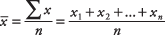
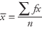
Grouped data on mean:
In statistics, we have studied the classification of data into a grouped and ungrouped frequency distribution. These data can be pictorially represented using different graphs such as bar graphs, frequency polygons and histograms and so on. Also, we know that the three measures of central tendencies are mean, median and mode. we will discuss how to find the mean of the grouped data using different methods such as direct method, assumed mean method and step deviation method with many solved examples.
Example: The marks scored by 30 students of PUC of a certain College in the Maths paper consisting of 100 marks is given below in the tabular form. Find the mean of the marks obtained by the class 10 students.
Marks | 40 -50 | 50 -60 | 60 -70 | 70 -80 | total
Number of students(f) | 5 | 15 | 5 | 5 | 30
x(mid point) | 45 | 55 | 65 | 75
fx | 225 | 825 | 325 | 375 | 1750
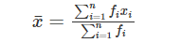
=1750/30=58.33 Mean marks obtained is 58.33
Three Methods to Find the Mean of Grouped Data
  - Direct Method
  - Assumed Mean Method
  - Step-Deviation Method
Direct method
Consider the same example as given above.
Now, convert the ungrouped data into grouped data by forming a class interval of width 15.
Note, that while taking the frequencies to each class interval, students falling in the upper-class limit will be considered in the next class interval.
Therefore, the grouped frequency distribution table for the above-given example is as follows:
Class Interval | 10-25 | 25-40 | 40-55 | 55-70 | 70-85 | 85-100
Number of Students | 2 | 3 | 7 | 6 | 6 | 6

For example, for the first class interval, 10-25, the class mark is:
Class Mark = (Upper class limit + lower class limit)/2
Class Mark = (25+10)/2 = 17.5
Similarly, find the classmark for all the intervals.

Therefore, the mean of the marks obtained by the students is given as:
Class Interval | Number of students (fi) | Class Mark (xi) | fixi
10-25 | 2 | 17 | 34
25-40 | 3 | 32 | 96
40-55 | 7 | 47 | 329
55-70 | 6 | 62 | 372
70-85 | 6 | 77 | 462
85-100 | 6 | 92 | 552
Total | Σfi = 30 |  | Σfixi = 1845

Therefore, Mean, x̄ = 1845/30 = 61.5
The mean value obtained using the direct method is 62.
Assumed Mean Method
If the numerical values of xi and fi are large, finding the product of xi and fi becomes a time-consuming process. To reduce the calculations, we can use the assumed mean method.(short cut method)
In this method, first, we need to choose the assumed mean, say “A” among the xi, which lies in the centre. (If we consider the same example, we can choose either a = 47 or 62). Now, let us choose a = 47.
The second step is to find the difference (di) between each xi and the assumed mean “a”.and divide by c the class interval d=X-A / C
The third step is to find the product of di with the corresponding fi.

Class Interval | Number of students (fi) | Class Mark (xi) | di = (xi – 47)/15 | fidi
10-25 | 2 | 17 | -2 | -4
25-40 | 3 | 32 | -1 | -3
40-55 | 7 | 47 | 0 | 0
55-70 | 6 | 62 | 1 | 6
70-85 | 6 | 77 | 2 | 12
85-100 | 6 | 92 | 3 | 18
Total | Σfi = 30 |  |  | Σfidi = 29
Mean= A + (∑d_{i}f_{i} /∑f_{i}) /C
=47+(29/30) x 15= 47 + (0.967) x 15=47+14.505=61.505
=61.5

Mean of ungrouped data:
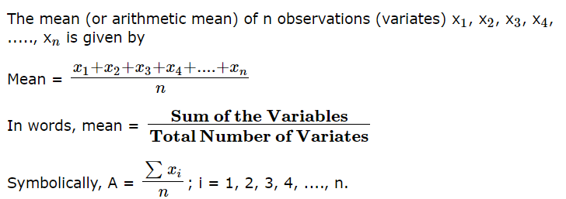
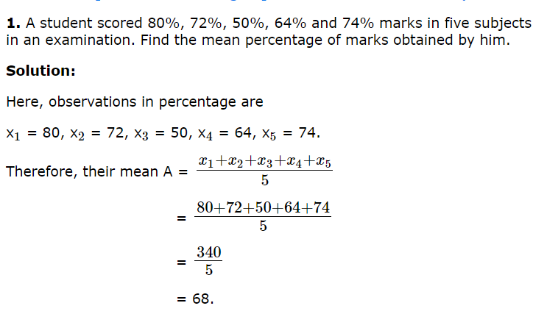
Note: ∑xi= nA, i,e., sum of variates = mean× number of variates.

Merits of Arithmetic Mean
- The arithmetic mean is simple to understand and easy to calculate.
- It is influenced by the value of every item in the series.
- A.M is rigidly defined.
- It has the capability of further algebraic treatment.
- It is a measured value and not based on the position in the series.

Demerits of Arithmetic Mean
- It is changed by extreme items such as very small and very large items.
- It can rarely be identified by inspection.
- In some cases, A.M. does not represent the original item. For example, the average number of patients admitted to a hospital are 10.7 per day.
- The arithmetic mean is not suitable in extremely asymmetrical distributions.

Properties of Arithmetic mean
1.Every set of interval-level and ratio-level data has a mean.
2. All the values are included in computing the mean.
3. A set of data has a unique mean.
4.The mean is affected by unusually large or small data values.
5.The arithmetic mean is the only measure of location where the sum of the deviations of each value from the mean is zero.

Some more examples:

Grouped data on Arithmatic mean:
While calculating the mean of the grouped data, the values x1, x2, x3, ……. xn are taken as the mid-values or the class marks of various class intervals. If the frequency distribution is inclusive, then it should be first converted to exclusive distribution.
The following table shows the number of plants in 20 houses in a group
Number of Plants | 0 - 2 | 2 - 4 | 4 - 6 | 6 - 8 | 8 - 10 | 10 - 12 | 12 - 14
Number of Houses | 1 | 2 | 2 | 4 | 6 | 2 | 3

Find the mean number of plants per house

Number of Plant | Number of Houses  (fi) | Class Mark  (xi) | fixi
0 - 2 | 1 | 1 | 1 × 1 = 1
2 - 4 | 2 | 3 | 2 × 3 = 6
4 - 6 | 2 | 5 | 2 × 5 = 10
6 - 8 | 4 | 7 | 4 × 7 = 28
8 - 10 | 6 | 9 | 6 × 9 = 54
10 - 12 | 2 | 11 | 2 × 11 = 22
12 -14 | 3 | 13 | 3 × 13 = 39
∑fi= 1 + 2 + 2 + 4 + 6 + 2 + 3 = 20
∑fixi=1 + 6 + 10 + 28 + 54 + 22 + 39 = 160
Therefore, mean = ∑(fixi)/ ∑fi= 160/20 = 8 plants

Ungrouped data on Arithmatic mean:
Arithmetic mean (AM) is one of the measures of central tendency which can be defined as the sum of all observations divided by the number of observations.
Formula to find arithmetic mean :
= Sum of all observations / Number of observations
Example:The marks obtained by 10 students in a test are 15, 75, 33, 67, 76, 54, 39, 12, 78, 11. Find the arithmetic mean.
Solution :Mean =Total marks of 10 students / 10
= (15 + 75 + 33 + 67 + 76 + 54 + 39 + 12 + 78 + 11) / 10
=460 / 10
=46

Median
Median is the middle value of the given data set. Usually, the data is arranged in ascending order before determining the median. If there are an odd number of observations, the median is the value represented by the middle of the data set. However, when there are an even number of observations, the median will be calculated as the mean of the two middle values.
Grouped data:
1. Obtain class boundaries.
2. Find less than cumulative frequencies of all the classes in data.
3. Compute N/2 and compare this quantity with less than cumulative frequencies. Choose less than cumulative frequency (CF) which is equal to or just exceeds the N/2. the class corresponding to this less than CF is k/a median class in which median lies.
Apply the formula and find median
Median: L = lower boundary of median class
N = total frequency
M = cumulative frequency of the class previous to the median class
f = frequency of median class
c= class width
Example: If the heights of 5 people are 142 cm, 150 cm, 149 cm, 156 cm, and 153 cm.
Find the median height.

Mean height,
x̄ = (142 + 150 + 149 + 156 + 153)/5
= 750/5
= 150
Median= 142 149 150 153 156 , After arranging them in ascending order , the middle number is 150 and that is median
.

Weighted Mean

Definition The weighted mean is defined as the summation of the product of weights and quantities, divided by the summation of weights. The of the weighted mean is quite often used in accounts, to give different weights based on time or based on priority.

Weighted Mean
=∑wixi / ∑wi=
w₁x₁ + w₂x₂ + w₃x₃ + w₄x₄ + w₅x₅) / (w₁ + w₂ + w₃ + w₄ + w₅)
Example: Find weighted mean for following data set w = {2, 5, 6, 8, 9}, x = {4, 3, 7, 5, 6}
Solution:
Given data sets w = {2, 5, 6, 8, 9}, x = {4, 3, 7, 5, 6} and N = 5
Weighted mean = ∑(weights × quantities) / ∑(weights)
= (w₁x₁ + w₂x₂ + w₃x₃ + w₄x₄ + w₅x₅) / (w₁ + w₂ + w₃ + w₄ + w₅)
= (2 × 4 + 5 × 3 + 6 × 7 + 8 × 5 + 9 × 6) / (2 + 5 + 6 + 8 + 9)
= ( 8 + 15 + 42 + 40 + 54) / 30
= 159 / 30= 5.3
Therefore, the weighted mean is 5.3.

Some merits of median are:
(1) Easy to calculate and understand | It is easy to calculate and simple to understand.  In many situations, the median can be located simply by inspection.
(2) Not affected by extreme values | It is not affected by the extreme values, i.e., the largest and smallest values because it is a positional average and not dependent on magnitude.
(3) Rigidly defined | It has a definite and certain value because it is rigidly defined.
(4) Best average in case of qualitative data | Median is the best measure of central tendency when we deal with qualitative data, where ranking is preferred instead of measurement or counting.
(5) Useful in case of an open-ended distribution | It can be calculated even if the values of the extremes are not known. However, the number of items should be known.
(6) Represented graphically | Its value can be determined or represented graphically with the help of ogive curves. Whereas, it is not possible in case of an arithmetic mean.
Some demerits of median are:
(1) Arrangement of data is necessary | Since the median is an average position, arranging the data in ascending or descending order of magnitude is time-consuming in case of a large number of observations.
(2) Not based on all the observations | It is a positional average and does not consider the magnitude of the items.., It neglects the extreme values.
(3) Not a representative of the universe | It is not dependent on all the observations, so it cannot be considered as their good representative. In case there is a big variation between the data, it will not be able to represent the data.
(4) Affected by fluctuations in sampling | It is affected by the fluctuations in sampling and this effect is more than that in case of an arithmetic mean.
(5) Lack of further algebraic treatment | It is a positional average, so further algebraic treatment is not possible. Example: We cannot compute the combined median of two groups of data.

Mode
Mode is the observation in the data set which occurs most frequently. In other words, the value that has repeated more times in a data set is called its mode. Mode can sometimes have multiple values. In certain cases where all the values are unique, the mode does not exist at all.
grouped data:
1.Obtain class boundaries.
2.Locate the model class is the class which has maximum frequency.
3.Find mode by using formula.
Mode: I=lower boundary of modal class
Fm =frequency of modal class
F1=frequency of pre modal class
F2=frequency of post modal class
h=width of modal class
Find the observation which occurs the maximum number of times.

Formula For grouped data Mode =
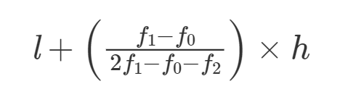
Example :

Find the mode of the given data.
Class | Frequency
50-55 | 2
55-60 | 7
60-65 | 8
65-70 | 4
Solution:
Here 8 is the maximum class frequency
Here modal class is 60-65
Class size, h = 65-60 = 5
Mode = l + [(f1– f0)/(2f1– f0– f2)]c
f1= 8
f0= 7
f2= 4
l = 60
So mode = 60 + ((8-7)/(16 – 7 – 4)]5
= 60 + (1/5)5= = 61

Mode of Ungrouped Data
For ungrouped data, we need to determine the observation that appears maximum times.

For example, the number of students in 1010 different classes is as follows:
3,6,4,5,0,2,1,3,2,33,6,4,5,0,2,1,3,2,3

The given data set is ungrouped data without a frequency table.
Here,33 is the number of students in the maximum number of classes. Hence, the mode of the data is33.

Merits:
(1) EASY TO CALCULATE & SIMPLE TO UNDERSTAND | - It is very easy to calculate.  - In some cases, it can be determined just by observation or inspection.  - Everyone understands the concept of majority. Since, mode is based on this concept, it is easy to understand.
(2) REPRESENTATIVE VALUE | - It is a value around which there is maximum concentration of observations.  - Hence, it is the best representative of the data.
(3) NOT AFFECTED BY THE VALUE OF EXTREME ITEMS | - It is not affected by extreme values of the given data.  - It can be calculated even if these extreme observations are not known.
(4) NO NEED OF COMPLETE DATA | - We can find mode even in case of open-ended frequency distribution.  - We basically need the point of maximum concentration of frequencies, it is not necessary to know all the values.
(5) USEFUL FOR BOTH QUANTITATIVE & QUALITATIVE DATA | - It can be used to describe quantitative as well as qualitative data.  - For example: In the surveys it is used to measure taste and preferences of people for a particular brand of the commodity.
(6) GRAPHIC DETERMINATION | - It can be determined graphically with the help of Histogram.
SOME OF THE DEMERITS OF MODE:

(1) NOT BASED ON ALL THE OBSERVATIONS OF THE SERIES | - The value of mode is not based on each and every item of the series as it considers only the highest concentration of frequencies.
(2) SOMETIMES IT IS INDETERMINATE OR ILL DEFINED | - Value of mode may not be determined always.  - Some distributions can be Bi-modal, Tri-modal or Multi-modal.
(3) NOT RIGIDLY DEFINED | - There are two methods of determining mode, Inspection Method and Grouping Method. We may not get the same value of mode by the two methods. So, it is not rigidly defined.
(4) AFFECTED BY THE FLUCTUATIONS OF SAMPLING | - Mode is affected by sampling fluctuations to a great extent.  - This effect is more than that in case of Mean.
(5) COMPLEX GROUPING PROCESS | - Grouping of data is desirable for correct computation but it is a complex process and involves so much calculations.
(6) NOT CAPABLE OF ALGEBRAIC TREATMENT | - Since it is not based on all the observations and not rigidly defined, it is not suitable for further algebraic treatment.

Relationship Between Mean, Median, and Mode of a Data Set:
The relation between the values of mean, median, and mode of a given data set is established by empirical formula. Empirical formula states that the mode of a distribution is equal to the subtraction of 2 times its mean from 3 times its median.
Empirical Relation:
Mean-Mode = 3(Mean-Median)
Or
Mode = 3 Median – 2 Mean

QUARTILES:

Quartiles : The value which divide the given data in to four equal parts when observations are arranged in order of magnitude are k/a quartiles.

There are three quartiles Q1,Q2&Q3.

a) Q1 (1st quartile): 25% below and 75% above

b) Q2 (2nd quartile): same as median 50% above and below

c) Q3 (3rd quartile): 75th below and 25% above.

Suppose Q₃ is the upper quartile is the median of the upper half of the data set. Whereas Q₁ is the lower quartile and median of the lower half of the data set. Q₂ is the median. Consider, we have n number of items in a data set. Then the quartiles are given by:
Q₁ = [(n+1)/4]th item
Q₂ = [(n+1)/2]th item
Q₃ = [3(n+1)/4]th item

the formula for quartile for the grouped data can be given by;
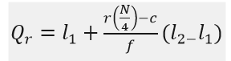
Where, Qr is the r^{th} quartile ., l₁ is the lower limit ,l₂ is the upper limit
f is the frequency, c is the cumulative frequency of the class preceding the quartile class
First quartile: 25% from smallest to largest of numbers Second quartile: between 25.1% and 50% (till median) Third quartile: 51% to 75% (above the median) Fourth quartile: 25% of largest numbers
FORMULA :
Grouped data :
- Q2=l+((2n/4-m)/f)*C
- Q1=l+((n/4-m)/f)*C
- Q3=l+((3n/4-m)/f)*C

Quartiles Examples:
Question 1: Find the quartiles of the following data: 4, 6, 7, 8, 10, 23, 34.
Solution: Here the numbers are arranged in the ascending order and number of items, n = 7
Lower quartile, Q₁ = [(n+1)/4] th item
Q₁= 7+1/4 = 2nd item = 6
Median, Q₂ = [(n+1)/2]th item
Q₂= 7+1/2 item = 4th item = 8
Upper Quartile, Q₃ = [3(n+1)/4]th item
Q₃ = 3(7+1)/4 item = 6th item = 23.

Question 2: Find the Quartiles of the following age:-
23, 13, 37, 16, 26, 35, 26, 35
Solution:
First, we need to arrange the numbers in increasing order.
Therefore, 13, 16, 23, 26, 26, 35, 35, 37
Number of items, n = 8
Lower quartile, Q₁ = [(n+1)/4] th item
Q₁ = 8+1/4 = 9/4 = 2.25th term
From the quartile formula we can write;
Q₁ = 2nd term + 0.25(3rd term-2nd term)
Q₁= 16+0.25(23-26) = 15.25
Similarly,
Median, Q₂ = [(n+1)/2]th item
Q₂ = 8+1/2 = 9/2 = 4.5
Q₂ = 4th term+0.5 (5th term-4th term)
Q₂= 26+0.5(26-26) = 26
And,
Upper Quartile, Q₃ = [3(n+1)/4]th item
Q₃ = 3(8+1)/4 = 6.75th term
Q₃ = 6th term + 0.75(7th term-6th term)
Q₃ = 35+0.75(35-35) = 35

Measures of Dispersion
Measures of dispersion are non-negative real numbers that help to gauge the spread of data about a central value. These measures help to determine how stretched or squeezed the given data is. There are five most commonly used measures of dispersion. These are range, variance, standard deviation, mean deviation, and quartile deviation.
The most important use of measures of dispersion is that they help to get an understanding of the distribution of data. As the data becomes more diverse, the value of the measure of dispersion increases. In this article, we will learn about measures of dispersion, their types along with examples as well as various important aspects related to these measures.

What is Measure of Dispersion in Statistics?
Measures of dispersion help to describe the variability in data. Dispersion is a statistical term that can be used to describe the extent to which data is scattered. Thus, measures of dispersion are certain types of measures that are used to quantify the dispersion of data.

Measures of Dispersion Definition
Measures of dispersion can be defined as positive real numbers that measure how homogeneous or heterogeneous the given data is. The value of a measure of dispersion will be 0 if the data points in a data set are the same. However, as the variability of the data increases the value of the measures of dispersion also increases.

Measures of Dispersion Example
Suppose we have two data sets A = {3, 1, 6, 2} and B = {1, 5, 9, 10}. The variance(population) of A is 3.5 and the variance(population) of B is 12.68. This implies that data set B is more variable than data set A. Thus, the variance helps to draw a comparison between the two data sets A and B on the basis of variability.
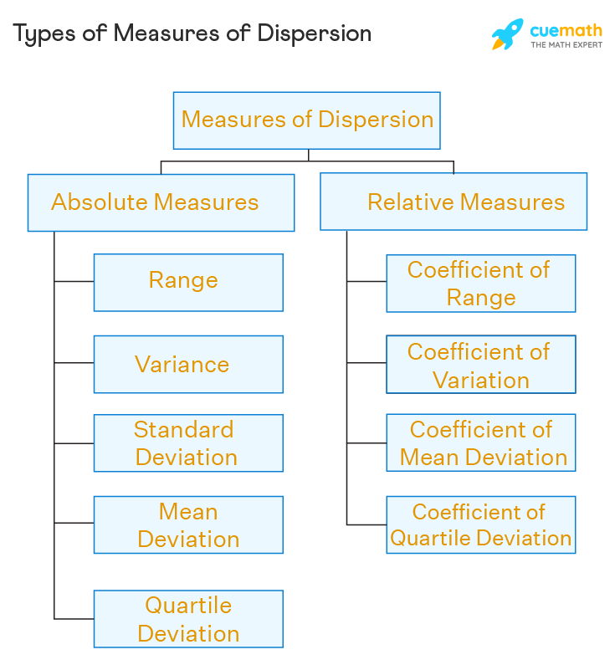

Properties of Good Measure of Variation
- It should be simple to understand.
- Its computation procedure should be simple.
- It should be rigidly defined.
- It should be based on all the values.
- It should not be affected too much by abnormal extreme values.
- It should be capable of further algebraic treatment.
- It should be stable.

Important measure of variation in common use are:
- Range
- Quartile Deviation
- Inter Quartile range
- Mean Deviation
- Standard deviation
- Coefficient of Variation
Range
Range refers to the difference between each series’ minimum and maximum values. A range is the most common and easily understandable measure of dispersion. It is the difference between two extreme observations of the data set. If X max and X min are the two extreme observations then
Range = X max – X min
Merits of Range
- It is the simplest of the measure of dispersion
- Easy to calculate
- Easy to understand
- Independent of change of origin
Demerits of Range
- It is based on two extreme observations. Hence, get affected by fluctuations
- A range is not a reliable measure of dispersion
- Dependent on change of scale
Quartile Deviation
The Quartile Deviation (QD) is the product of half of the difference between the upper and lower quartiles. Mathematically we can define as:
Quartile Deviation = (Q3 – Q1) / 2
Where Q3 and Q1 are 3rd quartile and 1st quartile respectively.
Q1=l+{(N/4-m)/f}×c
(same as your Median formula. But here we divide into 4 parts. So 1st quartile , it should be N/4. 2nd quartile is same as Median. So the formula comes to be
Q2=M = l+{(2N/4-m)/f}×c

Inter Quartile range
The formula for finding the inter quartile range takes the third quartile value and subtracts the first quartile value.
Inter Quartile range= Q3-Q1

Mean Deviation
It is the deviation from the mean value. But the property of Mean says that the sum of the deviation from the mean value is equal to zero.
Hence here while summing the deviation we neglect the sign and add.
So its modulus of sum x-x_{m}
MD=∑|x−¯x|/n
The arithmetic mean of the absolute values of the deviations from the arithmetic mean.

The main features of the mean deviation are:
All values are used in the calculation.
It is not unduly influenced by large or small values.
The absolute values are difficult to manipulate.

MD= ∑│(x – Mean)f│/ ∑f
(for grouped data)

Standard Deviation
Is the positive square root of mean of the squared deviations of the values from the arithmetic mean
σ =√{∑│(x – Mean)² / n-1} if n<30
σ =√ ∑│(x – Mean) ² / n} if n>=30

Variance
- In statistics, variance measures variability from the average or mean. It is calculated by taking the differences between each number in the data set and the mean, then squaring the differences to make them positive, and finally dividing the sum of the squares by the number of values in the data set.
- Variance = ∑│(x – Mean) ² / n
- Variance =∑ {(x-x_{m})² x f} / ∑f (for grouped data)

Coefficient of Variation
- CV= ( SD/ Mean )X 100

- Coefficient of variation tells us the percentage variation from the mean whereas SD just gives you the deviation from the mean

- Example 1: Find the population standard deviation of the data set {1, 3, 6, 7, 12}.
Solution: Standard deviation is a measure of dispersion given by the formula √∑n1(X−¯¯¯¯¯X)2n∑1n(X− X¯)2n.
n = 5
X¯ = (1 + 3 + 6 + 7 + 12) / 5 = 5.8
S.D = √(1−5.8)2+(3−5.8)2+(6−5.8)2+(7−5.8)2+(12−5.8)25(1−5.8)2+(3−5.8)2+(6−5.8)2+(7−5.8)2+(12−5.8)25 = 3.76
Answer: Standard deviation = 3.76

- Example 2: Find the sample variance of the data set {2, 6, 12, 15}
Solution: Variance is a measure of dispersion given by ∑n1(Xi−¯¯¯¯¯X)2n−1∑1n(Xi−X¯)2n−1
n = 4
¯¯¯¯¯XX¯ = (2 + 6 + 12 + 15) / 4 = 8.75
Variance = (2−8.75)2+(6−8.75)2+(12−8.75)2+(15−8.75)23(2−8.75)2+(6−8.75)2+(12−8.75)2+(15−8.75)23 = 34.25
Answer: Variance = 34.25
- Example 3: Find the range and coefficient of range of the data set {8, 12, 5, 6, 8, 2,15}
Solution: Range is a measure of dispersion given by Highest value (H) - Smallest value(S)
H = 15, S = 2
Range = 15 - 2 = 13
Coefficient of Range = (H - S) / (H + S) = 13 / 17 = 0.76
Answer: Range = 13, Coefficient of Range = 0.76

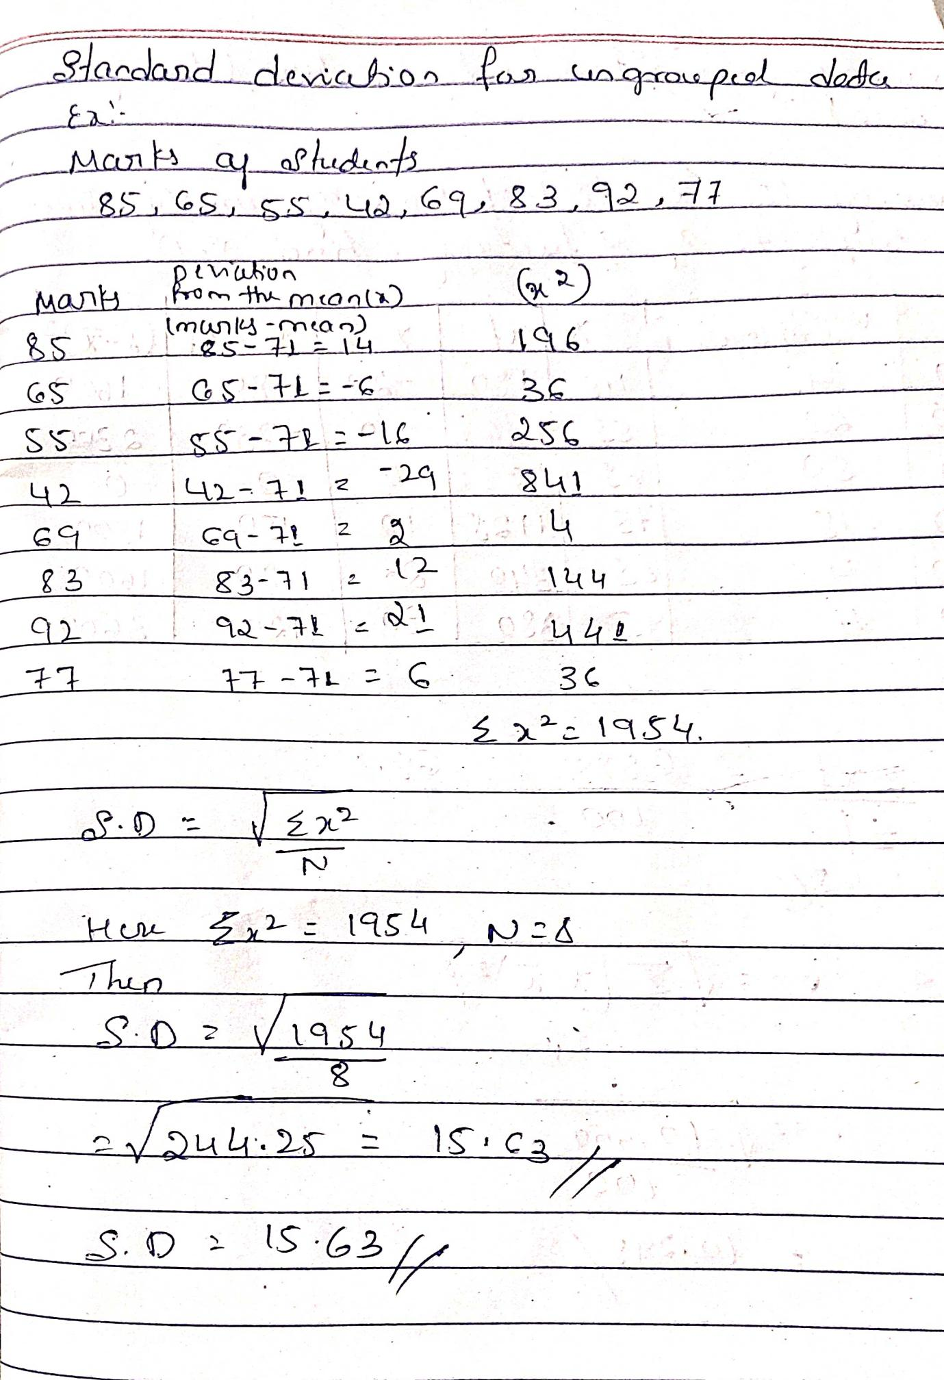

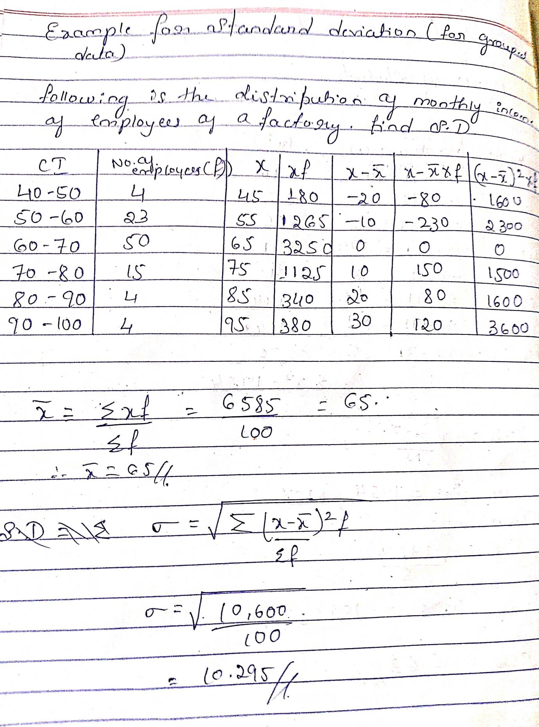

Normal Distribution
The Normal Distribution some times also called as the Gaussian Distribution or Z Distribution is the most important probability Distribution in statistics for independent random variables. And most people recognize it as Bell-Shaped Curve.
The Normal Distribution is a continuous probability Distribution that is symmetrical around its mean and most of the observations are clustered or grouped around the central peak and the probability for values further away from the mean toper off or shrink equally in both the direction.

Properties or Characteristics of Normal Distribution :
- If we draw a graph for Normal Distribution then it looks like a Bell Shaped one.
- All the 3 Measures of Central Tendency are lies at the middle and have single peak at the center of the Distribution.
- The Normal Distribution is the Symmetrical about the mean and half above the mean.
- The Distribution can be described by two values; The mean and the Standard Deviation.
- The mean determines where the peak of the curve is centered. Increasing the mean moves the right while decreasing it moves the curve left.
- Normal Distribution is an Asymptotical Distribution i.e, it can take any values from -∞ to +∞.
- The Normal Distribution is Unimodal that is the Distribution has the single peak.
- Empirical Rule also called as 68-95-99 Rule.

Normal Distribution Diagram :

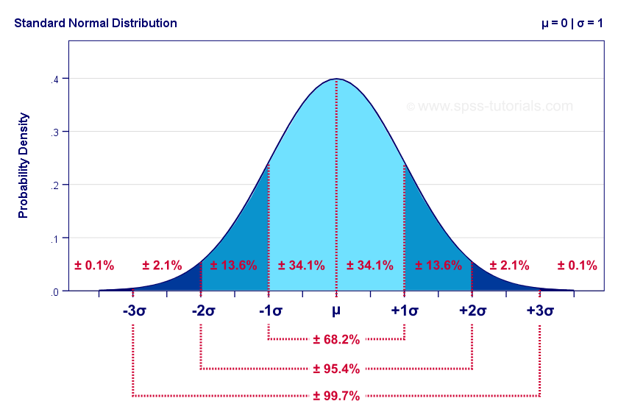
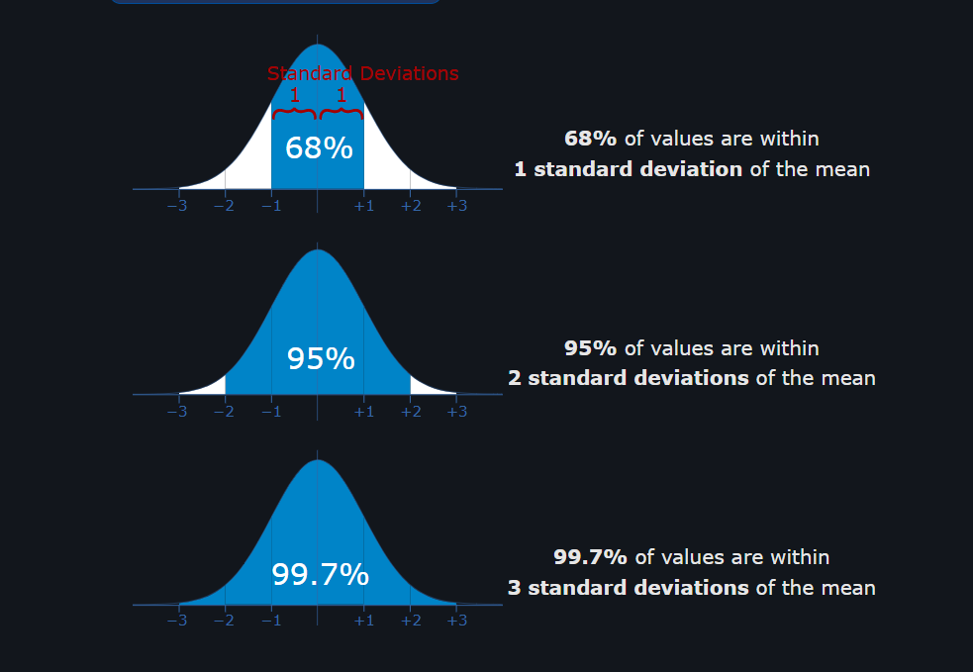
Z -Score :
It tells us how many Standard Deviation the X above or below i.e right and left of the mean.
So a Z -Value is the Distance between a selected value and designated value by X in the population mean divided by the population Standard Deviation.

Formula:
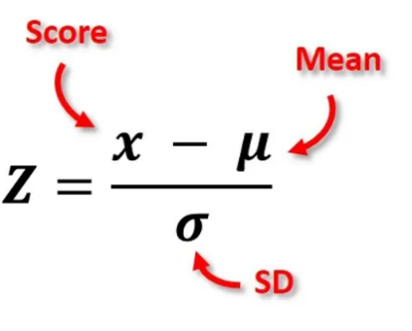
Example :

- Weight at birth of babies is a Normal Variation with the Mean 3.5kgs and Standard Deviation of 0.5kgs
- Find the Probability that a new born baby weights less than 2.5kgs.
- What percentage of bay would you expect to weight from 3.0 to 4.5kgs and
- >4.0kgs
Ans:
- <2.5kgs :
= 50 - (95.45/2) = 2.27

- Between 3.0 and 4.5kgs :
= (3.0 to 3.5) + (3.5 to 4.5)
= (68.26/2) + (95.44/2) = 81.85
- >4.0 :
50 – (68.26/2) = 15.87

Measures of Shape: Skewness and Kurtosis

The measure of central tendency and measure of dispersion can describe the distribution but they are not sufficient to describe the nature of the distribution. For this purpose, we use other two statistical measures that compare the shape to the normal curve called Skewness and Kurtosis.
Skewness and Kurtosis are the two important characteristics of distribution that are studied in descriptive statistics.

Skewness
Skewness is a statistical number that tells us if a distribution is symmetric or not. A distribution is symmetric if the right side of the distribution is similar to the left side of the distribution.
If a distribution is symmetric, then the Skewness value is 0.
i.e. If a distribution is Symmetric (normal distribution): median= mean= mode, (Skewness value is 0).

Types of skewness
1)Positively skewed
A positively skewed or right skewed distribution is a type of distribution in which
most values are clustered around the left tail of the distribution while the right tail if the
distribution is longer.
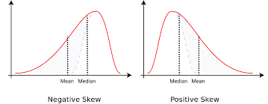

2) Negatively skewed
A negatively skewed or right skewed distribution is a type of distribution in which
More values are concentrated on the right tail of the distribution while the left tail if the
distribution is longer.



Examples of Skewed Distribution

1. Cricket Score
Cricket score is one of the best examples of skewed distribution. Let us say that during a match, most of the players of a particular team scored runs above 50, and only a few of them scored below 10. In such a case, the data is generally represented with the help of a negatively skewed distribution. Similarly, a positively skewed distribution can be used if most of the players of a particular team score badly during a match, and only a few of them tend to perform well.
Another example,

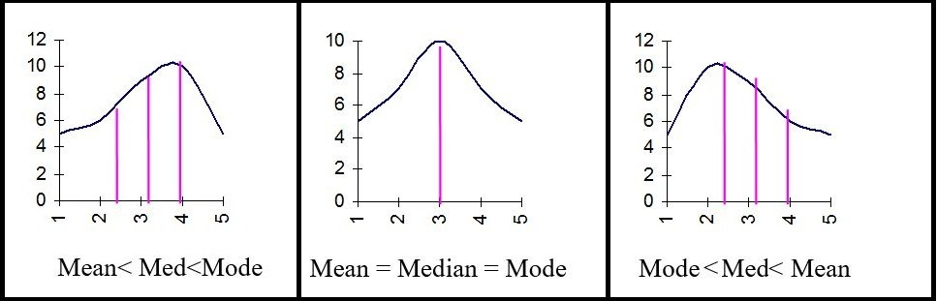

Measuring Skewness
Skewness can be measured using several methods; however, Pearson mode skewness and Pearson median skewness are the two frequently used methods. The Pearson mode skewness is used when a strong mode is exhibited by the sample data. If the data includes multiple modes or a weak mode, Pearson’s median skewness is used.
Types:
a)Pearson’s coefficient of skewness:
=mean-mode /standard deviation
=3(mean-median)/standard deviation

Karl Pearson coefficient of skewness formula with Example 1
The number of students absent in a class was recorded every day for 60 days and the information is given in the following frequency distribution.
No.of Students absent (x) | 0 | 1 | 2 | 3 | 4 | 5 | 6
No.of days (f) | 3 | 6 | 18 | 18 | 8 | 5 | 2
Find the Karl Pearson coefficient of skewness.
Solution
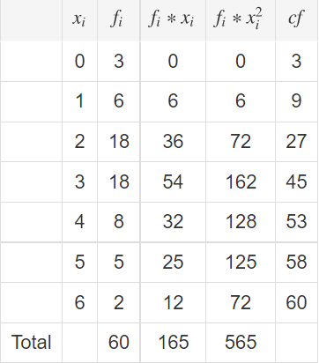

Sample mean
The sample mean of X is
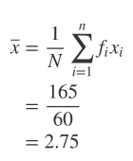

The average no. of students absent is 2.75 students
Since the given frequency distribution is bimodal,Karl Pearson’s coefficient of skewness can be calculated by using empirical formula.
For asymmetric distribution,

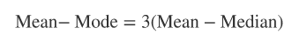

Thus, Karl Pearson’s coefficient of skewness can be calculated by
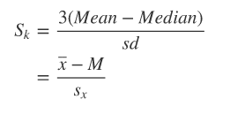

Sample Median
Median no. of students absent is
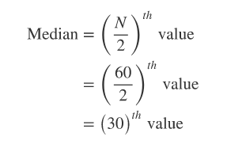

The cumulative frequency just greater than or equal to 30 is45.The corresponding value of
x is median. That is, M=3.

Thus, median number of accidents M=3

Sample variance
Sample variance of X is
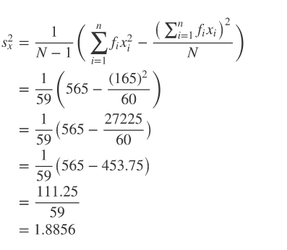

Sample standard deviation
The standard deviation is the positive square root of the variance.
The sample standard deviation is
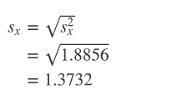

Thus the standard deviation of no. of students absent is 1.3732 students.

Karl Pearson’s coefficient of skewness
The Karl Pearson coefficient of skewness can be calculated by

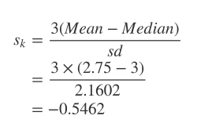
As the value of _{SK>0}, the data is negatively skewed.

b)Bowley’s coefficient of skewness:
S=(Q3+Q1-2M) / (Q3-Q1)
Example 1
The following table gives the number of children of 80 families in a village
No.of children | 0 | 1 | 2 | 3 | 4 | 5
No. of families | 12 | 23 | 16 | 9 | 10 | 10
Find the Bowley’s coefficient of skewness.

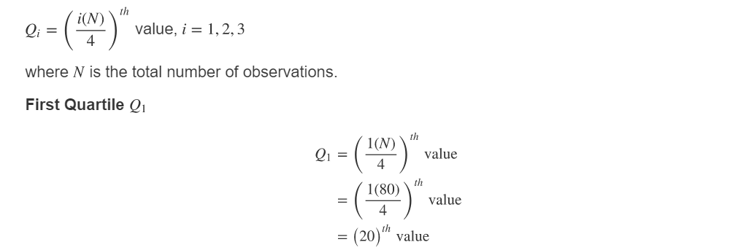

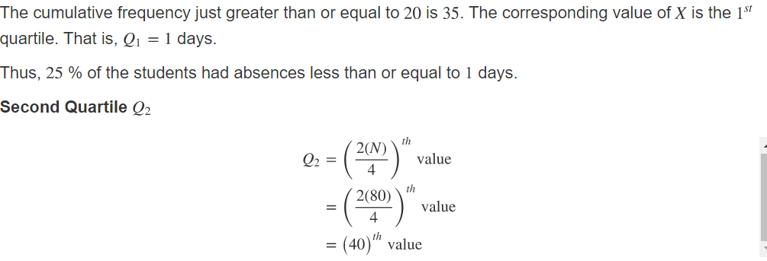

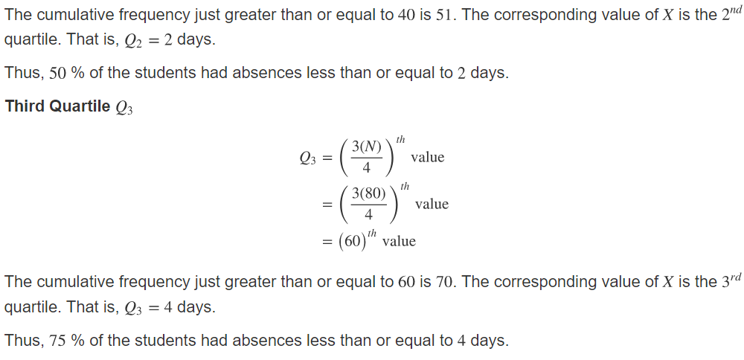
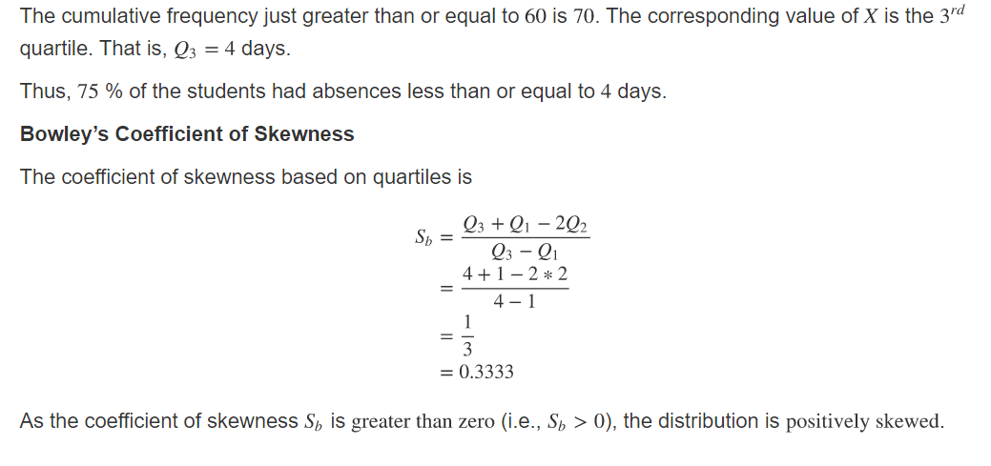

c)Based on Moments:
S=u₃²/u₂³

2 - Kurtosis
Kurtosis is a statistical number that tells us if a distribution is taller or shorter than a normal distribution. If a distribution is similar to the normal distribution, the Kurtosis value is 0. If Kurtosis is greater than 0, then it has a higher peak compared to the normal distribution. If Kurtosis is less than 0, then it is flatter than a normal distribution.

Three types of Distribution

a)Leptokurtic:
Sharply peaked with fat tails, and less variable.

*B>3

b)Mesokurtic:
Medium peaked

*B=3

c)Platykurtic:
Flattest peak and highly dispersed.

*B<3
Examples of Kurtosis,
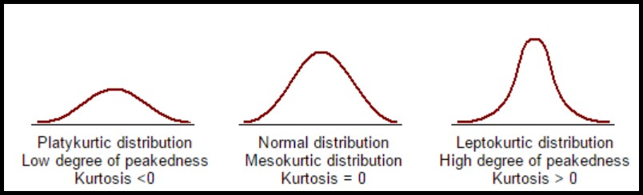
Formula :
β=u₄/u₂²
u2=second moment about mean
u4=fourth moment about mean
Problems

Find the measure of kurtosis based on the moment for the following data

x | 2 | 3 | 4 | 5 | 6
f | 1 | 3 | 7 | 3 | 1

Solution:
x | f | fx | x-x̄ | (x-x̄)² | f*(x-x̄)² | (x-x̄)⁴ | f*(x-x̄)⁴
2 | 1 | 2 | -2 | 4 | 4 | 16 | 16
3 | 3 | 9 | -1 | 1 | 3 | 1 | 3
4 | 7 | 28 | 0 | 0 | 0 | 0 | 0
5 | 3 | 15 | 1 | 1 | 3 | 1 | 3
6 | 1 | 6 | 2 | 4 | 4 | 16 | 16
∑ f=15 ∑fx=60 ∑f*(x-x̄)²=14 ∑f*(x-x̄)⁴=38

β= u_{4 /}u₂²
u₂=∑f*(x-x̄)² / ∑f
=14/15
=0.933
x̄=∑fx / ∑f
=60/15
=4
u₄=∑f(x-x̄)⁴ / ∑f
=38/15
=2.533
β=2.533/ (0.933)²
=2.533/0.8704
=2.91
*β<3 the distribution is platykurtic
Fundamental differences between skewness and kurtosis:

- The characteristic of a frequency distribution that ascertains its symmetry about the mean is called skewness. On the other hand, Kurtosis means the relative pointedness of the standard bell curve, defined by the frequency distribution.
- Skewness is a measure of the degree of lopsidedness in the frequency distribution. Conversely, kurtosis is a measure of degree of tailed Ness in the frequency distribution.
- Skewness is an indicator of lack of symmetry, i.e. both left and right sides of the curve are unequal, with respect to the central point. As against this, kurtosis is a measure of data, that is either peaked or flat, with respect to the probability distribution.
- Skewness shows how much and in which direction, the values deviate from the mean? In contrast, kurtosis explain how tall and sharp the central peak is.
Correlation

Correlation

Correlation is a bivariate analysis that measures the strength of association between two variables and the direction of the relationship. In terms of the strength of relationship, the value of the correlation coefficient varies between +1 and -1. A value of ± 1 indicates a perfect degree of association between the two variables. As the correlation coefficient value goes towards 0, the relationship between the two variables will be weaker. The direction of the relationship is indicated by the sign of the coefficient; a + sign indicates a positive relationship and a – sign indicates a negative relationship
Positive Correlation: The correlation is said to be positive correlation if the values of two variables changing with same direction. Ex. Height & weight.
Negative Correlation: The correlation is said to be negative correlation when the values of variables change with opposite direction. : Ex. Price & qty. demanded
Positive correlation_ As X increases Y increases and also As X decreases Y decreases :E.g., As height increases, so does weight; water consumption and temperature.;study time and grades.
Negative correlation:: As X increases Y decreases and Also As X decreases Y increases
- Eg: As TV time increases, grades decrease; alcohol consumption and driving ability.;Price & quantity demanded

Types of correlation:
- Simple correlation: Under simple correlation problem there are only two variables are studied.
- Multiple Correlation: Under Multiple Correlation three or more than three variables are studied.
- Partial correlation: analysis recognizes more than two variables but considers only two variables keeping the other constant.

Correlation Coefficient Formula: Definition

Correlation coefficient formulas are used to find how strong a relationship is between data. The formulas return a value between -1 and 1, where:
- 1 indicates a strong positive relationship.
- -1 indicates a strong negative relationship.
- A result of zero indicates no relationship at all.

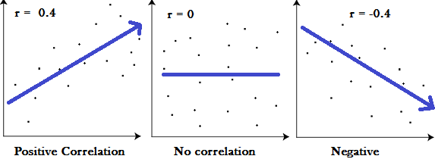

Correlation coefficient | Correlation strength | Correlation type
-.7 to -1 | Very strong | Negative
-.5 to -.7 | Strong | Negative
-.3 to -.5 | Moderate | Negative
0 to -.3 | Weak | Negative
0 | None | Zero
0 to .3 | Weak | Positive
.3 to .5 | Moderate | Positive
.5 to .7 | Strong | Positive
.7 to 1 | Very strong | Positive

Scatter Diagram – Definition
A scatter diagram is used to examine the relationship between both the axes (X and Y) with one variable. In the graph, if the variables are correlated, then the point drops along a curve or line. A scatter diagram or scatter plot gives an idea of the nature of relationship.
In a scatter correlation diagram, if all the points stretch in one line, then the correlation is perfect and is in unity. However, if the scatter points are widely scattered throughout the line, then the correlation is said to be low. If the scatter points rest near a line or on a line, then the correlation is said to be linear.

Types of correlation coefficient formulas.
There are several types of correlation coefficient formulas.
One of the most commonly used formulas is Pearson’s correlation coefficient formula. 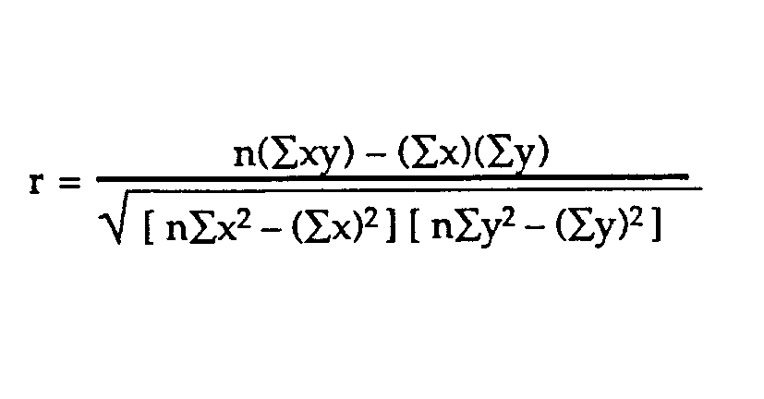

Pearson CorrelationCoefficient:
Correlation between sets of data is a measure of how well they are related. The most common measure of correlation in stats is the Pearson Correlation. Its also called as the Karl Pearson Product Moment Correlation (PPMC). Usually the notation r is used to represent the Pearson correlation:

Example question: Find the value of the correlation coefficient from the following table:

SUBJECT | AGE X | GLUCOSE LEVEL Y
1 | 43 | 99
2 | 21 | 65
3 | 25 | 79
4 | 42 | 75
5 | 57 | 87
6 | 59 | 81

SUBJECT | AGE X | GLUCOSE LEVEL Y | XY | X² | Y²
1 | 43 | 99 | 4257 | 1849 | 9801
2 | 21 | 65 | 1365 | 441 | 4225
3 | 25 | 79 | 1975 | 625 | 6241
4 | 42 | 75 | 3150 | 1764 | 5625
5 | 57 | 87 | 4959 | 3249 | 7569
6 | 59 | 81 | 4779 | 3481 | 6561
Σ | 247 | 486 | 20485 | 11409 | 40022

Use the following correlation coefficient formula.
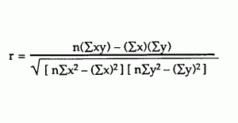
The answer is: 2868 / 5413.27 = 0.529

Spearman correlation coefficient: Definition

The Spearman’s rank coefficient of correlation is a nonparametric measure of rank correlation (statistical dependence of ranking between two variables).
Named after Charles Spearman, it is often denoted by the Greek letter ‘ρ’ (rho) and is primarily used for data analysis. If the data is not normal then we go for spearmans rank correlation where instead of taking original data weassign the ranks to the data and apply the formula
It measures the strength and direction of the association between two ranked variables. But before we talk about the Spearman correlation coefficient, it is important to understand Pearson’s correlation first. A Pearson correlation is a statistical measure of the strength of a linear relationship between paired data.

Spearman correlation coefficient: Formula and Calculation with Example
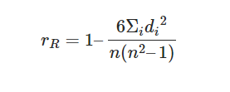
n= number of data points of the two variables
di= difference in ranks of the “ith” element
The Spearman Coefficient,⍴, can take a value between +1 to -1 where,
- A ⍴ value of +1 means a perfect association of rank
- A ⍴ value of 0 means no association of ranks
- A ⍴ value of -1 means a perfect negative association between ranks.

The scores of 9 students in History and Geography are mentioned in the table below.
Step 1- Create a table of the data obtained.
Step 2- Start by ranking the two data sets. Data ranking can be achieved by assigning the ranking “1” to the biggest number in the column, “2” to the second biggest number and so forth. The smallest value will usually get the lowest ranking. This should be done for both sets of measurements.
Step 3- Add a third column d to your data set, d here denotes the difference between ranks. For example, if the first student’s physics rank is 3 and the math rank is 5 then the difference in the rank is 3. In the fourth column, square your d values.
History | Rank | Geography | Rank | d | d square
35 | 3 | 30 | 5 | 2 | 4
23 | 5 | 33 | 3 | 2 | 4
47 | 1 | 45 | 2 | 1 | 1
17 | 6 | 23 | 6 | 0 | 0
10 | 7 | 8 | 8 | 1 | 1
43 | 2 | 49 | 1 | 1 | 1
9 | 8 | 12 | 7 | 1 | 1
6 | 9 | 4 | 9 | 0 | 0
28 | 4 | 31 | 4 | 0 | 0
 |  |  |  |  | 12
Step 4- Add up all your d square values, which is 12 (∑d square)
Step 5- Insert these values in the formula

=1-(6*12)/(9(81-1))
=1-72/720
=1-01
=0.9
The Spearman’s Rank Correlation for this data is 0.9 and as mentioned above if the ⍴ value is nearing +1 then they have a perfect association of rank.

Advantages
- A correlational study can be conducted on variables that can be measured and not manipulated, for example when an experimental method would be impractical or unethical to conduct.
- A correlation can demonstrate the presence or absence of a relationship between two factors so is good for indicating areas where experimental research could take place and show further results.

Disadvantages
- A correlational analysis can only be used when the variables are two measurable on a scale.
No cause and effect can be established in correlational research as its not certain that one variable caused another to happen, it could be one or the other or it could even

- Regression Analysis
is a very powerful tool in the field of statistical analysis in predicting the value of one variable, given the value of another variable, when those variables are related to each other. Regression is the study of the nature of relationship between the variables so that one may be able to predict the unknown value of one variable for a known value of another variable, With the help of regression, possible values of the dependent variable are estimated on the basis of the values of the independent variable.
USES OF REGRESSION

1. Nature of Relationship: Regression analysis explains the nature of relationship between two variables
2. Estimation of Relationship: The mutual relationship between two or more variables can be measured easily by regression analysis.
3. Prediction: By regression analysis, the value of a dependent variable can be predicated on the basis of the value of an independent variable. For example, if price of a commodity rises, what will be the probable fall in demand, this can be predicted by regression.
4. Useful in Economic and Business Research: Regression analysis is very useful in business and economic research. With the help of regression, business and economic policies can be formulated.
Simple Regression Analysis
In simple. regression analysis, we study only two variables at a time, in which one variable is dependent and another is independent. The relationship between income and expenditure is an example of simple regression.
formula for regression analysis
Y = a + bX
- Regression Equation of Y on X
In order to obtain the value of 'a' &'b' we have to frame the two equations as
Σy = na + bΣx
Σxy = aΣx + bΣx²
- Regression Equation of X on Y
In order to obtain the value of 'c' &'d'
Σx = nc + dΣy
Σyx = cΣy + dΣy²

In case of perfect correlation ( positive or negative ) the two line of regression coincide. If the two regression line are far from each other then degree of correlation is less, & vice versa. The mean values of X &Y can be obtained as the point of intersection of the two regression line. The higher degree of correlation between the variables, the angle between the lines is smaller & vice versa.
- Regression Equation of y on x: Y – Y_{m} = b_{yx} (X –X_{m})
where b_{yx} = ∑xy / ∑x² is the regression coefficient of Y on X
b_{yx =} r (σy / σx ) Y_{m}- Mean of Y ; X_{m}- Mean of X
- Regression Equation of x on y: X – X_{m} = b_{xy} (Y –Y_{m})
where b_{xy} = ∑xy / ∑y² is the regression coefficient of X on Y
b_{xy =} r (σx / σy )

Properties of the Regression Coefficients
1.The coefficient of correlation is geometric mean of the two regression coefficients. r = √ b_{yx *} b_{xy}
2.If b_{yx} is positive than b_{xy} should also be positive & vice versa.
3.If one regression coefficient is greater than one the other must be less than one.
4.The coefficient of correlation will have the same sign as that our regression coefficient.
5.Arithmetic mean of b_{yx &} b_{xy} is equal to or greater than coefficient of correlation. b_{yx +} b_{xy / 2 ≥} r
6.Regression coefficient are independent of origin but not of scale.
For Example :
Σx = 78 Σy = 84 Σxy = 673 Σx² = 636
Ans :-
84 = 10a +78b. ---- 1
673 =78a + 636b ---- 2
By solving
84 * 78 = 780a + (78)²b ---- 3
673 * 10 = 780a + 6360b ---- 4
Eqn 3 – 4 we get
178 = 276b; b = 178/276 b = 0.64
Substitute b=0.64 in equation
84 = 10a + 78b
84 = 10a + 78 * 0.64
10a = 84 – 78 * 0.64
10a = 84 – 49.92
a = 34.08/10
a = 3.41
From the above constants if we plot for x=5 thenv
Y = a + bX
Y = 3.41 + 0.64 * 5
Y =6.6
Example 2: After investigation it has been found the demand for automobiles in a city depends mainly, if not entirely, upon the number of families residing in that city. Below are the given figures for the sales of automobiles in the five cities for the year 2019 and the number of families residing in those cities.
City | No. of families (in lakhs) | Sale of automobiles(in '000)
Belagavi | 70 | 25.2
Bangalore | 75 | 28.6
Hubli | 80 | 30.2
Kalaburgi | 60 | 22.3
Mangalore | 90 | 35.4

Fit a linear regression equation of Y on X by the least square method and estimate the sales for the year 2020 for the city Belagavi which is estimated to have 100 lakh families assuming that the same relationship holds true.

Coefficient of determination
- It’s the measure of proportion of variability in the variable that can be explained by a linear relationship between the variables x and y and denoted by the term r²

Point Estimation
Point estimation is used when we want to estimate a single value of the population parameter we are interested in. The population parameter estimate is calculated from a sample.
Hence, the sample mean (x¯) is a point estimate of the real population mean (μ). Analogously, the sample variance (S²) is a point estimate of the population parameter (σ²), as the sample proportion (pˆ) is a point estimate of the population proportion (p).

Consider a luxury condominium with 702 lots. We would like to estimate the average size of the lots, their variance, as well as the proportion of lots for sale. In order to do that, a random sample with 60 lots is collected, revealing an average size of 1750 m² per lot, a variance of 420 m², and a proportion of 8% of the lots for sale. Thus:
a) x¯=1750 is a point estimate of the real population mean (μ);
b) S² = 420 is a point estimate of the real population variance (σ²); and
c) pˆ=0.08 is a point estimate of the real population proportion (p).
(c)
Confidence intervals

A point estimate provides no information about the precision and reliability of estimation.
For example, the sample mean X is a point estimate of the population mean μ but because of sampling variability, it is virtually never the case that x= μ
A point estimate says nothing about how close it might be to μ.
An alternative to reporting a single sensible value for the parameter being estimated it to calculate and report an entire interval of plausible values – a Confidence Interval (CI).
An interval estimate of a parameter obtained from a sample with a certain probability the estimate will contain the parameter
Proabability of including the true value of a parameter within a confidence interval
Confidence Limits: Two extreme measurements within which an observation lies Or End points of the Confidence level.
• Confidence interval for the population mean.
• Confidence interval for the population proportion.

Confidence interval for Mean

Population should normally distributed. Or Large samples
Formula: μ +/- Zvalue x sd /√n
Formula: ps +/- Zα √ ps(1- ps)/ n
95% confidence interval for a population proportion (denoted by μ)
If we were to take 100 different samples and find the confidence interval using each of them, approximately 95 of these intervals would actually enclose μ within their limits.
Z= 1.96 at 5% (95%)
Z= 2.58 at 1% (99%)
Types of variables:
Variable: Characteristic which changes from person to person in a study.
We tend to classify variables as qualitative or quantitative.
1. A qualitative variables measures levels/categories for which it would not make sense to describe the levels/categories according to a mathematical relation.
2. A quantitative variables has numerical values for which it does make sense to compare and contrast these values using a mathematical relations.

Problems
1) A random sample of 50 people shows that 15 are above the age of 60 years

Ans: ps +/- Zα √ ps(1- ps)/ n
= 0.15 +/- 1.96 √ 0.15*0.85/50
= 0.248 and 0.052
2) A random sample of 25 people shows that 25 are left handed. Form a 99% confidence interval for the true population of left handers.

Ans: ps +/- Zα √ ps(1- ps)/ n
= 0.25 +/- 2.58 √ 0.25(1-0.25)/25
= 0.25 +/- 0.70
= 0.95
3.A sample of 20 people from a large population has a mean height as 155 cms and standard deviation of 10. Find the 95% confidence interval
Ans: µ +/- Zvalue x sd /√n = 155 +/- 1.96 *(10/√20) = 1.55 +/- 4.3828
= 159.38 and 150.62 2.
4.A random sample of n=30 has mean= 100 and SD= 6 form a 99% confidence interval for µ.
Ans: µ +/- Zvalue x sd /√n = 100 +/- 2.58 * 6/√30 = 100 +/- 2.812 = 102.812 and 97.188

Z-score
Z-score is also known as standard score gives us an idea of how far a data point is from the mean. It indicates how many standard deviations an element is from the mean. Hence, Z-Score is measured in terms of standard deviation from the mean. For example, a standard deviation of 2 indicates the value is 2 standard deviations away from the mean. In order to use a z-score, we need to know the population mean (μ) and also the population standard deviation (σ).
The Formula for Z-Score
A z-score can be calculated using the following formula.
z = (X – μ) / σ
where,
z = Z-Score,
X = The value of the element,
μ = The population mean, and
σ = The population standard deviation

How to Calculate Z-Score?
Usually, the population mean ((μ), the population standard deviation (σ), and the observed value (x) are provided in the problem statement, and substituting the same in the above Z-score equation yields us the Z-Score value. Depending upon whether the given Z-Score is positive or negative, one makes use of the respective positive Z-Table or negative Z-Table

Example:

Question:
You take the GATE examination and score 500. The mean score for the GATE is 390 and the standard deviation is 45. How well did you score on the test compared to the average test taker?

Solution:
The following data is readily available in the above question statement
Raw score/observed value = X = 500
Mean score = μ = 390
Standard deviation = σ = 45

By applying the formula of z-score,

z = (X – μ) / σ
z = (500 – 390) / 45
z = 110 / 45 = 2.44

This means that your z-score is 2.44.

Since the Z-Score is positive 2.44, we will make use of the positive Z-Table.

Now let’s take a look at Z Table (CC-BY) to know how well you scored compared to the other test-takers.

Follow the instruction below to find the probability from the table.

Here, z-score = 2.44

1.Firstly, map the first two digits 2.4 on the Y-axis.
2.Then along the X-axis, map 0.04
3.Join both axes. The intersection of the two will provide you the Z-Score value you’re looking for

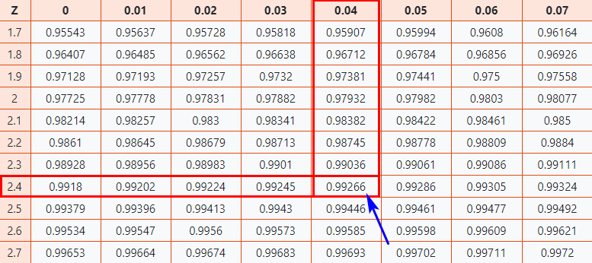
As a result, you will get the final value which is 0.99266.

Now, we need to compare how our original score of 500 on the GATE examination compares to the average score of the batch. To do that we need to convert the Z-Score into a percentage value.

0.99266 * 100 = 99.266%

Finally, you can say that you have performed well than almost 99% of other test-takers.

Interpretation of Z-score
•An element having a z-score less than 0 represents that the element is less than the mean.
•An element having a z-score greater than 0 represents that the element is greater than the mean.
•An element having a z-score equal to 0 represents that the element is equal to the mean.
•An element having a z-score equal to 1 represents that the element is 1 standard deviation greater than the mean; a z-score equal to 2, 2 standard deviations greater than the mean, and so on.
•An element having a z-score equal to -1 represents that the element is 1 standard deviation less than the mean; a z-score equal to -2, 2 standard deviations less than the mean, and so on.
•If the number of elements in a given set is large, then about 68% of the elements have a z-score between -1 and 1; about 95% have a z-score between -2 and 2; about 99% have a z-score between -3 and 3. This is known as the Empirical Rule or the 68-95-99.7 Rule and can be demonstrated in the image below

Statistical parameter

- Descriptive statistics - describes the data for eg, Mean, median, standard deviation, percentages
- Inferential statistics: Make inferences from the data to more general conditions

Statistical Inference

There are two types of statistical inferences:
- Estimation of population parameters and hypothesis testing.
Hypothesis testing is one of the most important tools of application of statistics to real life problems. Most often, decisions are required to be made concerning populations on the basis of sample information. Statistical tests are used in arriving at these decisions.

Statistical significance is very important in research not only in Mathematics but in several different fields such as medicine, psychology and biology. There are many methods through which the significance can be tested. These are known as significance tests.
In statistics, it is important to know if the result of an experiment is significant enough or not. In order to measure the significance, there are some predefined tests which could be applied. These tests are called the tests of significance or simply the significance tests.
This statistical testing is subjected to some degree of error. For some experiments, the researcher is required to define the probability of sampling error in advance. In any test which does not consider the entire population, the sampling error does exist. The testing of significance is very important in statistical research.
The significance level is the level at which it can be accepted if a given event is statistically significant. This is also termed as p-value. It is observed that the bigger samples are less prone to chance, thus the sample size plays a vital role in measuring the statistical significance. One should use only representative and random samples for significance testing.
In short, the significance is the probability that a relationship exists. Significance tests tell us about the probability that if a relationship we found is due to random chance or not and to which level. This indicates about the error that would be made by us if the found relationship is assumed to exist.
Technically speaking, the statistical significance refers to the probability of a result of some statistical test or research occurring by chance. The main purpose of performing statistical research is basically to find the truth. In this process, the researcher has to make sure about the quality of sample, accuracy, and good measures which need a number of steps to be done. The researcher has to determine whether the findings of experiments have occurred due to a good study or just by fluke.
The significance is a number which represents probability indicating the result of some study has occurred purely by chance. The statistical significance may be weak or strong. It does not necessarily indicate practical significance. Sometimes, when a researcher does not carefully make use of language in the report of their experiment, the significance may be misinterpreted.
The psychologists and statisticians look for a 5% probability or less which means 5% results occur due to chance. This also indicates that there is a 95% chance of results occurring NOT by chance. Whenever it is found that the result of our experiment is statistically significant, it refers that we should be 95% sure the results are not due to chance.

There are two types of statistical inferences: That is Estimation of population parameters and hypothesis testing. Hypothesis testing is one of the most important tools of application of statistics to real life problems. Most often, decisions are required to be made concerning populations on the basis of sample information. Statistical tests are used in arriving at these decisions

Hypothesis testing
Hypothesis testing or significance testing is a method for testing a claim or hypothesis about a parameter in a population, using data measured in a sample. In this method, we test some hypothesis by determining the likelihood that a sample statistic could have been selected, if the hypothesis regarding the population parameter were true.
A hypothesis in statistics is simply a quantitative statement about a population. For example a coin may be tossed 100 times and we may get heads 60 times and tails 40 times. So now our interest is to test the hypothesis that the coin is unbiased.

4 Steps of Hypothesis

The goal of hypothesis testing is to determine the likelihood that a population parameter, such as the mean, is likely to be true
Step 1: State the hypotheses.
Step 2: Set the criteria for a decision.
Step 3: Compute the test statistic.
Step 4: Make a decision. Interpretation based on standard value

Step 1: State the hypotheses. We begin by stating the value of a population mean in a null hypothesis, which we presume is true.
The null hypothesis (H0), stated as the null, is a statement about a population parameter, such as the population mean, that is assumed to be true. The null hypothesis is a starting point. We will test whether the value stated in the null hypothesis is likely to be true. Or we say that there is no real difference in the sample and the population in the particular matter under consideration. For example if we want to find out whether extra coaching has benefitted the students or not, we shall set up a null hypothesis that extra coaching has not benefitted the students. The rejection of null hypothesis indicates that the differences have statistical significance and the acceptance of the null hypothesis indicates that the differences are due to chance.
An alternative hypothesis (H1) is a statement that directly contradicts a null hypothesis by stating that that the actual value of a population parameter is less than, greater than, or not equal to the value stated in the null hypothesis. The alternative hypothesis states what we think is wrong about the null hypothesis, which is needed. It specifies those values that the researcher believes to hold true.
Step 2: Set the criteria for a decision. To set the criteria for a decision, we state the level of significance for a test.
Level of significance, or significance level, refers to a criterion of judgment upon which a decision is made regarding the value stated in a null hypothesis. The criterion is based on the probability of obtaining a statistic measured in a sample if the value stated in the null hypothesis were true. In general the criterion or level of significance is typically set at 5%. When the probability of obtaining a sample mean is less than 5% if the null hypothesis were true, then we reject the value stated in the null hypothesis.
Step 3: Setting a test criterion
The test statistic is a mathematical formula that allows researchers to determine the likelihood of obtaining sample outcomes if the null hypothesis were true. The value of the test statistic is used to make a decision regarding the null hypothesis. It involves selecting an appropriate probability distribution for the particular test. Some probability distribution commonly used in testing procedure are students unpaired and paired t test, F test, Chisquare test .

Step 4: Make a decision. We use the value of the test statistic to make a decision about the null hypothesis. The decision is based on the probability of obtaining a sample mean, given that the value stated in the null hypothesis is true. If the probability of obtaining a sample mean is less than 5% when the null hypothesis is true, then the decision is to reject the null hypothesis. If the probability of obtaining a sample mean is greater than 5% when the null hypothesis is true, then the decision is to retain the null hypothesis. In sum, there are two decisions a researcher can make:
1. Reject the null hypothesis. The sample mean is associated with a low probability of occurrence when the null hypothesis is true.
2. Retain the null hypothesis. The sample mean is associated with a high probability of occurrence when the null hypothesis is true.
The probability of obtaining a sample mean, given that the value stated in the null hypothesis is true, is stated by the p value. The p value is a probability: It varies between 0 and 1 and can never be negative. As we stated the criterion or probability of obtaining a sample mean at which point we will decide to reject the value stated in the null hypothesis, which is typically set at 5% in behavioral research. To make a decision, we compare the p value to the criterion
Functions of statistics to test the significance
1.Tests of differences between groups (independent samples);
2.Tests of differences between variables (Pre to Post) (dependent samples)
3.Tests of relationships between variables.(Quantitative)
4.Prediction of dependent variable
5. Association between factors
The researcher must first decide whether a parametric or nonparametric test must be selected
To have the parametric test we should see that the data satisfy some of the assumptions.
1. assumes that the variable measured is normally distributed in the population
2. the data must represent an interval or ratio scale of measurement
3. the selection of participants is independent
4. the variances of the population comparison groups are equal
There are two general research strategies that can be used to compare the two populations of interest: The two samples could be drawn from two independent populations (e.g. women and men, or Group A vs. Group B) That means two independent groups
Similalry the two sets of data could come from related populations (e.g. “before treatment” and “after treatment” To find out the effect of academic performance before giving the notes and after the distribution of notes.

The commonly used test of significance is students t test. For independent groups we use students unpaired t test and for dependent group students paired t test will be applied. Also for independent groups, if the sample size is large enough then Z(Gaussian test) will be applied

Examples for independent groups:
1.Compare the number of hours spent at library by the MBA and M,Sc students at a post graduation centre
2.Self esteem of working and non working women
3.QOL of Care takers of Cancer and AIDS patients

Students unpaired t test formula

Estimate the standard error of the difference using the common pooled variance :

degrees of freedom (df).= n₁+n₂-2

Dependent samples are samples that are paired or related in some fashion

where d= Mean of the differences and s_{d} is the standard deviation of the differences.

n=number of pairs

Eg.In a study of hematological changes in trained athletes following prolonged exercise, haemoglobin levels(in g/dl) were measured in 10 athletes before & after their participation in a continuous 60 kilometer march. Do the results presented below offer any evidence of hematological change following such a sustained period of exercise? (t value at 9 df =2.262 at 0.05 level)

Slno | 1 | 2 | 3 | 4 | 5 | 6 | 7 | 8 | 9 | 10
Before | 14.5 | 17.4 | 11.9 | 12.5 | 16.5 | 12 | 11.5 | 15.8 | 13.8 | 16.2
After | 13.8 | 15.0 | 11.0 | 11.5 | 16.2 | 12.5 | 11.8 | 15 | 14.2 | 15

